#### Spelt Waffle Recipe

* 250g wholemeal spelt flour
* 1 tsp baking powder
* 1 heaped tablespoon honey
* 3/4 teaspoon fine sea salt
* 450ml milk, of choice
* 2 large eggs
* 20g unsalted butter, melted

#### Method

Crack the eggs into a bowl, gradually add the milk, then the honey, whisking to combine. Sift in the flour, baking powder and salt then whisk until fully combined. Add the cooled melted butter and gradually stir it through the mixture. It's important not to stir the mixture too much or your waffles may be tough.

Either pre-heat your waffle iron and cook according to manufacturers instruction or us a griddle pan to make them.

To make with a griddle pan: You can do this by greasing a griddle pan with a little melted butter and placing it over a high heat. Once hot, pour in the waffle batter in and tilt the pan to spread it around evenly. Lower the heat to low and cook the waffles for around 6-7 minutes, or until lightly golden on the bottom. Carefully flip the mixture over and continue to cook for the same time on the other side.

[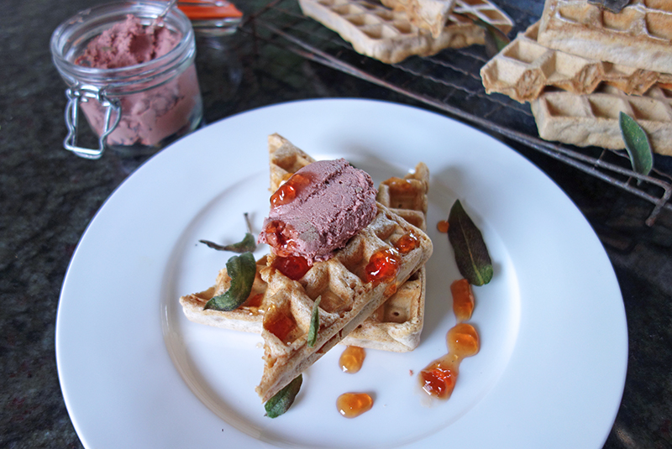](http://tessward.com/wp-content/uploads/2015/03/DSC00405.jpg)

#### Chicken Liver Pate and Sage Leave Recipe

If you fancy impressing friends, you could serve half a waffle as an elegant starter, or even cut into quarters and handed out as canapé nibbles too.

* 350g organic chicken livers, cleaned and trimmed
* 100g unsalted butter, diced
* 1 small onion, finely chopped
* 3-4 sprig fresh thyme
* 60ml brandy
* 75ml creme fraiche
* ½ tsp salt
* 1 ground allspice
* a small handful of sage leaves (approx 14-16)
* 1 tablespoon butter

#### Method

Heat a knob of butter in a frying pan over a medium-low heat. Add the chopped onion and thyme leaves and cook over a low flame until the onion turns soft and translucent, them turn into a food processot. Return the pan back to the stove, increasing the heat to medium-high and a knob of butter and the livers. Fry the livers for 1-2 minutes on each sides until browned on the outside but still pink inside. Then add the livers to the processor with the onion.  
Return the frying pan back to the heat ad deglaze with the brandy. Allow the mixture to reduce slightly, and for the alcohol to cook off, then add it to the food processor. Finally add the creme fraiche, salt and spices and whizz until smooth. Add all the butter, and whizz again. Taste for seasoning and adjust if need be.

Pass the liver mixture through a sieve into a large bowl, for a smooth and silky texture. Place the sieves mixture into a sealable jar, or ramekin and chill until set.

Heat the butter in a large frying pan, to melt and add the sage leaves in batches, frying on each side for half a minute or until crispy. Drain on kitchen towel and set aside for use.

[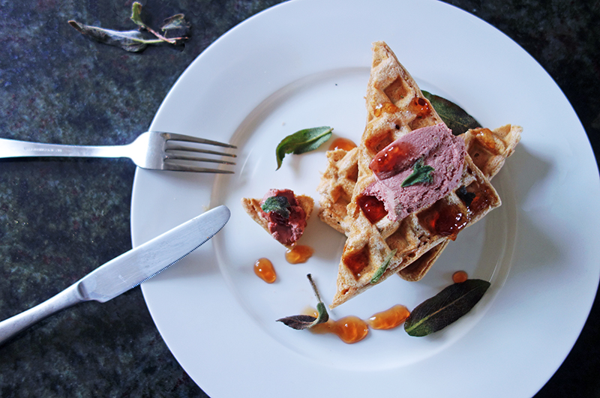](http://tessward.com/wp-content/uploads/2015/03/DSC00412.jpg)

Slice the waffles in half on the diagonal, or into quarters. Take 1 tablespoon of chicken liver pate and using a couple of spoons, shape it into a oval blob. Pop it on top of the waffles. Scatter over the sage leaves and drizzle over your chosen chutney or jelly.

Enjoy whilst the waffles are still warm.